**Predicting Brand Preference for Missing Values on Survey**

**Jeroen Meij**

30-01-2019

*Blackwell Data analytics department*

1. **Summary**

For this report, 3 different machine learning algorithms have been evaluated to predict respondents’ preferred computer brand in an incomplete survey. The method used are:

* C5.0 Decision tree
* Random Forest
* K-Nearest Neighbors

With the help of the ggplot2 package in, R the data was visualized to see how brand preference was distributed among the respondents. The caret package in R provided the tools to tune and run each machine learning algorithm efficiently. Variables that provided the most predictive power for consumers preferred brand were their yearly salary and their age.

With the predicted incomplete surveys and the complete surveys combined we know how many of the respondents prefer Sony over Acer and vice versa. As it turns out, 9,257 of the respondents prefers Sony over Acer and 5,641 of the respondents prefers Acer over Sony. Hence 62% of the respondents prefers Sony over Acer, and 38% prefers Acer over Sony.

With these numbers, it is clear that most respondents prefer Sony products. However, since this preference is both salary and age dependent, the management must first make a choice which type of customer they want to try to attract more before engaging with either Sony or Acer.

1. **Full report:**

**2.1) Objective:**

The sales team engaged a market research firm to conduct a survey of our existing customers. One of the objectives of the survey was to find out which of two brands of computers our customers prefer. Unfortunately, the data related to the brand preference was not properly captured for all of the respondents.

Therefore, I investigated whether customer responses to some survey questions (e.g. income, age, etc.) enabled us to predict the answer to the brand preference question.

**2.2) Data:**

Danielle Sherman provided me with 2 datasets:

* The completed surveys
* The surveys where brand prediction is missing

Table 1 contains the variables obtained from the survey:

Table 1: Variables obtained from survey

|  |  |  |
| --- | --- | --- |
| **Variables** |  | **Description** |
| Yearly salary |  | In USD |
| Age |  | In Years |
| Highest level of education obtained |  | 5 options |
| Primary car brand |  | 20 options |
| Zip code |  | 9 options |
| Amount of credit available |  | In USD |
| **Preferred brand** |  | **Variable of interest. 2 options** |

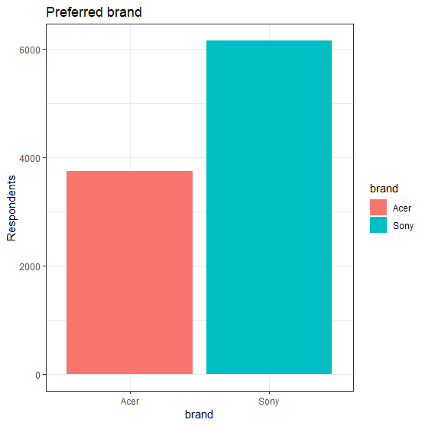Multiple plots have been evaluated to analyze the data. For reference, these can be found in the appendix of this report.

Figure 1: Bar chart for brand preference

When looking at the respondents´ preferred brand in the completed surveys data (**figure 1**), we see that more people have picked Sony instead of Acer. Overall, the percentage that picked Sony was: 62% whereas the percentage that picked Acer was 38%.

The thing that struck out the most was that there is a clear pattern observable when looking at the respondents’ yearly salary and their preferred brand. **Figure 2.1** provides a histogram, and **figure 2.2** provides a density plot on this relationship.

As we can see in the figures, respondents with a relatively lower yearly salary and respondents with a relatively higher yearly salary generally prefer Sony over Acer. People that have a relatively medium yearly salary however prefer Acer over Sony.

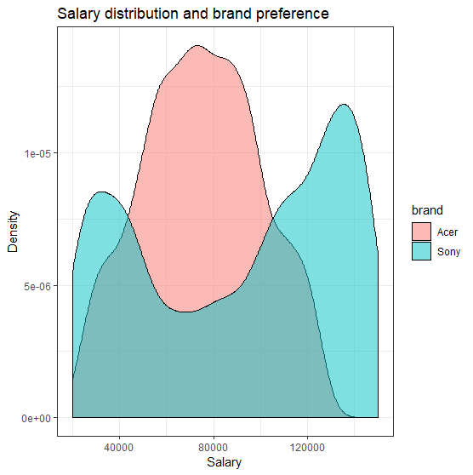

Figure 2.2: Density plot on sales and brand preference

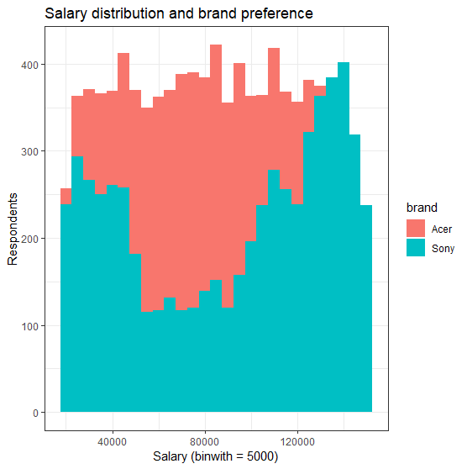

Figure 2.1: Histogram on sales and brand preference



**Figure 3** is a scatterplot with the respondents’ age and salary on respectively the x- and y-axis. The different colors provide their brand preference. Firstly, it provides us with the same insight as the previous figures have given: on average, respondents with a lower yearly salary and respondents a higher yearly salary generally prefer Sony over Acer and people that have a medium yearly salary prefer Acer over Sony.

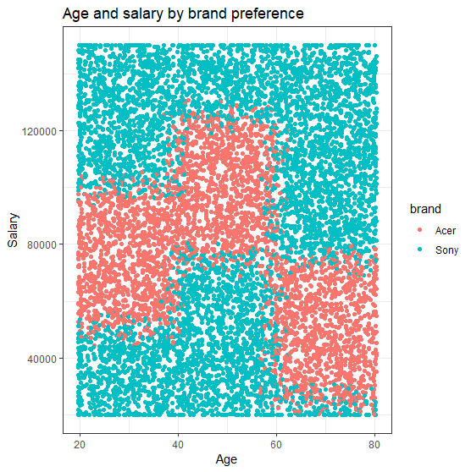

Figure 3: Scatterplot with age, salary and brand preference

Figure 3 however provides a more accurate overview regarding the distribution of these values in comparison to the previous figures. As it turns out, people aged 20 to 40 with lower-medium incomes prefer Acer over Sony. People aged 40 to 60 with higher-medium incomes prefer Acer over Sony. People aged 60 to 80 with low/lower-medium incomes prefer Acer over Sony. Although it was not apparent from the figures with age and brand preference as portrayed in the Appendix, age does seem to have an impact on the respondents’ preferred brand.

**2.3) Building an accurate predictive model:**

With help from the *caret* package in R, the data was split, the models were cross validated, parameters for each algorithm were finetuned, predictions were made and the outcomes were evaluated.

The complete survey with 9898 observations was split in 2 separate sets: 75% of the total observations was used to generate a set to train the models on, and the remaining 25% was used to generate a set to test the models on. The Caret package stratifies each set, so the training and testing set have similar distributions across the variables. Three algorithms have been used to generate a predictive model, all with very accurate results. The algorithms are:

* C5.0 Decision tree
* Random Forest
* K-Nearest Neighbors

Each algorithm had its own parameters to finetune, which was done as follows:

* For the C5.0 Decision Tree, I let the caret package automatically choose for the best parameters from a total of 40 tries.
* For the Random Forest and K-Nearest Neighbors I ran the parameters through a grid to determine the parameter which provided the most accurate model. The Random Forest parameter *Mtry*, (*the number of variables randomly sampled as candidates at each split)* was tested for values ranging from 1 to 20.
* The k-NN parameter k (*the number of nearest datapoints an unknown point will base its value on*) was tested for values ranging from 1 to 150.

In the k-NN prediction predictive variables were reduced to two: age and yearly salary. Both variables were normalized. The number of folds for cross validation was set to 10. The process was not repeated multiple times. The models with the best performing parameters were tested on the test-set and afterwards accuracy and Cohen´s kappa were calculated. The results are displayed in the next chapter.

**2.4) Model estimates:**

Complete tables of outcomes can be found in the Appendix. This chapter will give the parameters which performed the best, and the outcomes related to these parameters.

**Table 2.1, 2.2 and 2.3** contain the values optimizing the predictive model for the C5.0 Decision Tree, the Random Forest, and k-Nearest Neighbors, together with their cross validated accuracy and Kappa:

|  |  |  |  |  |  |
| --- | --- | --- | --- | --- | --- |
| **Model** | **Model** | **Winnow** | **Trials** | *Accuracy* | *Kappa* |
| C5.0 DT | Rules | FALSE | 40 | *0.922954* | *0.836243* |

Table 2.1: Parameter values for C5.0 DT

|  |  |  |  |  |
| --- | --- | --- | --- | --- |
| **Model** | **Ntrees** | **Mtry** | *Accuracy* | *Kappa* |
| Random Forest | 500 | 14 | *0.924031* | *0.838935* |

Table 2.2: Parameter values for Random Forest

|  |  |  |  |
| --- | --- | --- | --- |
| **Model** | **K** | *Accuracy* | *Kappa* |
| k-NN | 69 | *0.92713* | *0.84535* |

Table 2.3:: Parameter values for k-NN

Using these parameters on each model, the test-set’s preferred brand was predicted and evaluated against its real value. **Table 3.1, 3.2** and **3.3** contain the accuracy and kappa of each model, together with their confusion matrix.

**Figures 4.1, 4.2** and **4.3** show the wrongly predicted values per preferred brand, plotted on an age/salary scatter like the one in figure 3 on page 4. It is clearly observable that each model is accurate and fails around the same area: the borders of the age/salary groups where the demographics are split between a Sony preference and an Acer preference.

There are no areas distinguishable where one algorithm outshines the others. C5.0 Decision Tree puts most importance in variables that do not seem to have an extreme importance. Furthermore, k-NN uses only salary to predict preferred brand, whereas age also seems to matter. The Random Forest model will be used to evaluate the incomplete survey as it has the highest accuracy and kappa (although with values this close to each other, that doesn’t say anything).

|  |  |  |  |  |
| --- | --- | --- | --- | --- |
|  |  | **Reference** | |  |
|  | **Prediction** | **Acer** | **Sony** | *Prediction accuracy* |
|  | **Acer** | 841 | 105 | 0.889 |
|  | **Sony** | 95 | 1433 | 0.938 |
| *Reference accuracy* | | *0.899* | *0.932* |  |
| ***Test model accuracy*** | | |  | | --- | | 0.919 | | 0.826 | | |  |
| ***Kappa*** | |  |

|  |  |
| --- | --- |
| Top 3 variables of importance | |
| **age** | 100 |
| **salary** | 100 |
| **Chrysler** | 32.2 |

Table 3.1: Confusion matrix for the C5.0 predicted model and overall important variables.

|  |  |  |  |  |
| --- | --- | --- | --- | --- |
|  |  | **Reference** | |  |
|  | **Prediction** | **Acer** | **Sony** | *Prediction accuracy* |
|  | **Acer** | 844 | 105 | *0.889* |
|  | **Sony** | 92 | 1433 | *0.940* |
| *Reference accuracy* | | *0.902* | *0.932* |  |
| ***Test model accuracy*** | | |  | | --- | | 0.920 | | 0.831 | | |  |
| ***Kappa*** | |  |

|  |  |
| --- | --- |
| Top 3 variables of importance | |
| **salary** | 100 |
| **age** | 60.7 |
| **credit** | 12.1 |

Table 3.2: Confusion matrix for the Random Forest predicted model and overall important variables

|  |  |
| --- | --- |
| Top 2 variables of importance | |
| **salary** | 100 |
| **age** | 0 |

Table 3.3: Confusion matrix for the k-NN predicted model and overall important variables

|  |  |  |  |  |
| --- | --- | --- | --- | --- |
|  |  | **Reference** | |  |
|  | **Prediction** | **Acer** | **Sony** | *Prediction accuracy* |
|  | **Acer** | 846 | 111 | *0.884* |
|  | **Sony** | 90 | 1427 | *0.941* |
| *Reference accuracy* | | *0.904* | *0.928* |  |
| ***Test model accuracy*** | | 0.919  0.828 | |  |
| ***Kappa*** | |  |

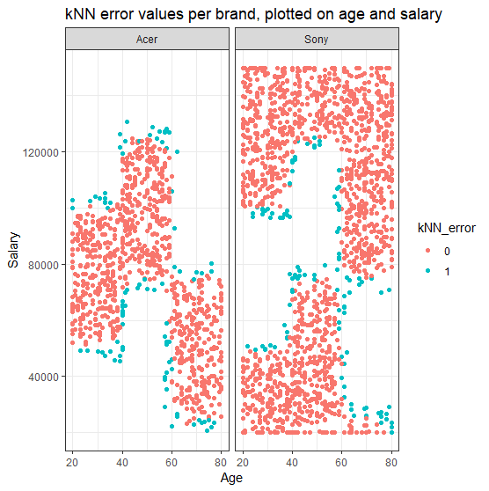

Figure 4.3: Errors from kNN model per brand

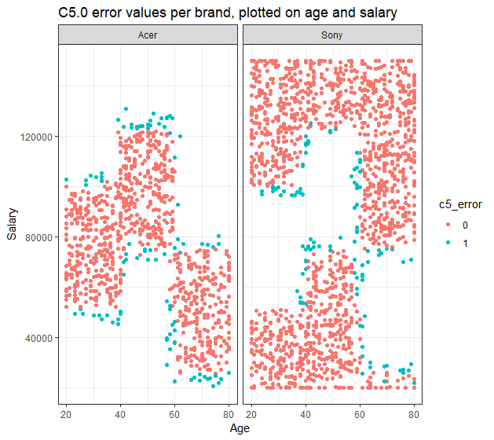

Figure 4.1: Errors from C5.0 Decision Tree model per brand

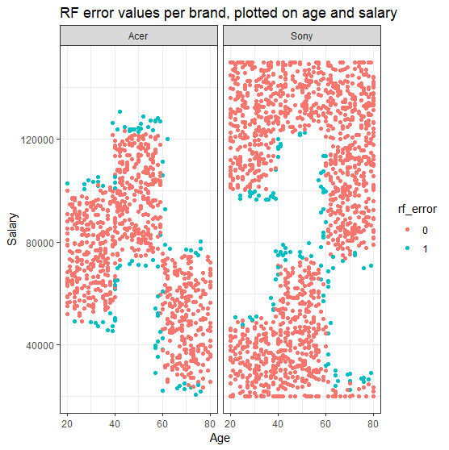

Figure 4.2 Errors from Random Forest model per brand

*the pink dots in the figure above display the correct predictions of a respondent’s preferred brand, the blue dots show the mis predicted brand preferences

1. **Conclusion**

The Random Forest model predicted the missing brand preferences for the incomplete survey data. Therefore, we now have a complete survey. However, it needs to be double checked to see whether the incomplete survey data does not consist of too many respondents in the age/salary ranges where all models had difficulties in predicting the correct preference. For now, the assumption is made that this is not the case and that we can rely on the outcome.

In the incomplete survey, 1897 respondents were predicted to prefer Acer over Sony. 3103 respondents were predicted to prefer Sony over Acer. This corresponds 38% of the respondents preferring Acer and 62% of the respondents preferring Sony. When combining these results with the complete survey, a total of 9,257 of the respondents prefers Sony and 5,641 of the respondents prefers Acer. Again, that is 62% of the respondents that prefers Sony over Acer, and 38% that prefers Acer over Sony.

This indicates that Sony is clearly in general the most preferred brand. However as has been shown in chapter 2 of this report, there are clear distinct groups within the respondents’ demography which prefer on over the other. Therefore, the choice of which brand to we should contact for more cooperation depends on which types of consumers Blackwell wants to attract the most. My suggestion for the management team are therefore as follows:

1. Make the data department and the marketing department do a thorough investigation on the differences between the specific consumer groups so we can answer the following questions:
   * Which groups are the most profitable?
   * Which groups does Blackwell want to affiliate with the most?
   * Which groups are the easiest to influence using marketing techniques?
   * Which groups tend to buy at Blackwell more often?
   * Etc.
2. With these questions answered, go back to the results in this data
3. Choose the brand to engage with more intensively based on the outcomes of all the research

Appendix

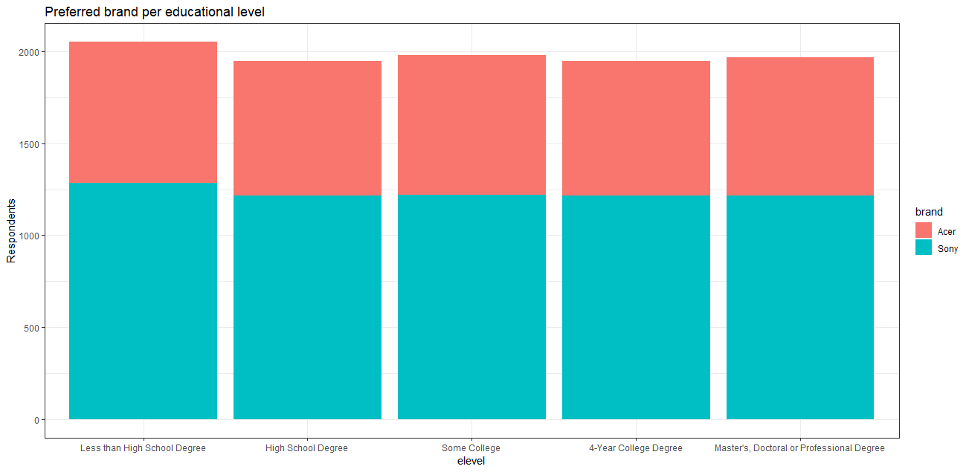

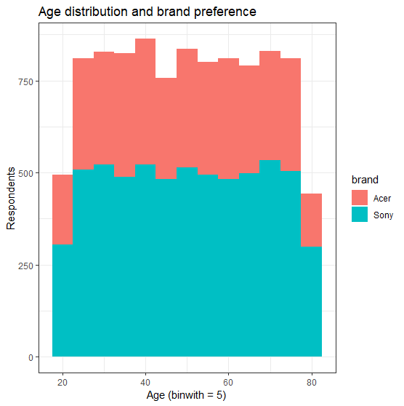

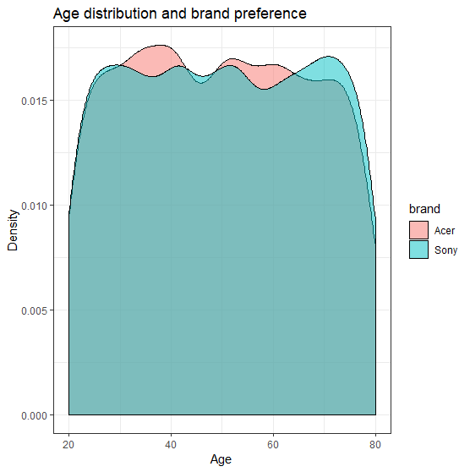

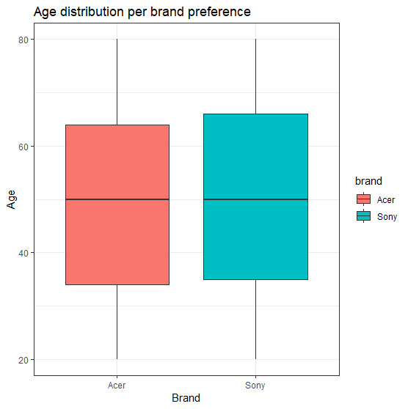

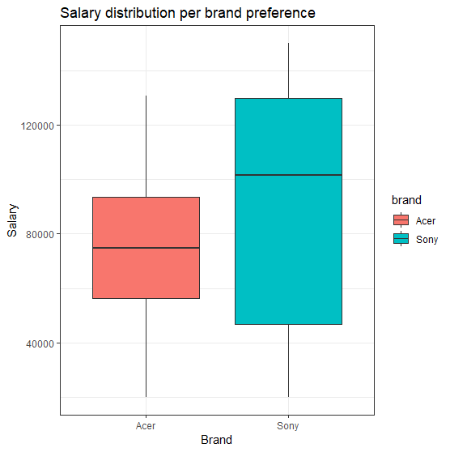

C5.0 values with Accuracy and Kappa

|  |  |  |  |  |
| --- | --- | --- | --- | --- |
| **model** | **winnow** | **trials** | **Accuracy** | **Kappa** |
| rules | FALSE | 1 | 0.817216 | 0.635935 |
| rules | FALSE | 10 | 0.921338 | 0.832118 |
| rules | FALSE | 20 | 0.922279 | 0.834744 |
| rules | FALSE | 30 | 0.922685 | 0.835612 |
| **rules** | **FALSE** | **40** | **0.922954** | **0.836243** |
| rules | FALSE | 50 | 0.922954 | 0.836243 |
| rules | FALSE | 60 | 0.922954 | 0.836243 |
| rules | FALSE | 70 | 0.922954 | 0.836243 |
| rules | FALSE | 80 | 0.922954 | 0.836243 |
| rules | FALSE | 90 | 0.922954 | 0.836243 |
| rules | TRUE | 1 | 0.812364 | 0.627283 |
| rules | TRUE | 10 | 0.908132 | 0.80693 |
| rules | TRUE | 20 | 0.908805 | 0.809052 |
| rules | TRUE | 30 | 0.908671 | 0.808784 |
| rules | TRUE | 40 | 0.90894 | 0.809415 |
| rules | TRUE | 50 | 0.90894 | 0.809415 |
| rules | TRUE | 60 | 0.90894 | 0.809415 |
| rules | TRUE | 70 | 0.90894 | 0.809415 |
| rules | TRUE | 80 | 0.90894 | 0.809415 |
| rules | TRUE | 90 | 0.90894 | 0.809415 |
| tree | FALSE | 1 | 0.810747 | 0.617911 |
| tree | FALSE | 10 | 0.920396 | 0.830939 |
| tree | FALSE | 20 | 0.921339 | 0.833293 |
| tree | FALSE | 30 | 0.920799 | 0.832121 |
| tree | FALSE | 40 | 0.920799 | 0.832121 |
| tree | FALSE | 50 | 0.920799 | 0.832121 |
| tree | FALSE | 60 | 0.920799 | 0.832121 |
| tree | FALSE | 70 | 0.920799 | 0.832121 |
| tree | FALSE | 80 | 0.920799 | 0.832121 |
| tree | FALSE | 90 | 0.920799 | 0.832121 |
| tree | TRUE | 1 | 0.811556 | 0.619308 |
| tree | TRUE | 10 | 0.922688 | 0.83539 |
| tree | TRUE | 20 | 0.920263 | 0.830647 |
| tree | TRUE | 30 | 0.92161 | 0.833474 |
| tree | TRUE | 40 | 0.92161 | 0.833474 |
| tree | TRUE | 50 | 0.92161 | 0.833474 |
| tree | TRUE | 60 | 0.92161 | 0.833474 |
| tree | TRUE | 70 | 0.92161 | 0.833474 |
| tree | TRUE | 80 | 0.92161 | 0.833474 |
| tree | TRUE | 90 | 0.92161 | 0.833474 |

Random Forest, grid for mtry = 1 to mtry = 20 with Accuracy and Kappa

|  |  |  |
| --- | --- | --- |
| **mtry** | **Accuracy** | **Kappa** |
| 1 | 0.621767 | 0 |
| 2 | 0.621902 | 0.000442 |
| 3 | 0.734645 | 0.367761 |
| 4 | 0.84469 | 0.66204 |
| 5 | 0.886314 | 0.758304 |
| 6 | 0.908539 | 0.806214 |
| 7 | 0.916082 | 0.822374 |
| 8 | 0.918239 | 0.826769 |
| 9 | 0.920933 | 0.832371 |
| 10 | 0.921876 | 0.834461 |
| 11 | 0.921606 | 0.833823 |
| 12 | 0.923762 | 0.838289 |
| 13 | 0.924031 | 0.838796 |
| **14** | **0.924031** | **0.838935** |
| 15 | 0.924031 | 0.838901 |
| 16 | 0.922954 | 0.836488 |
| 17 | 0.923357 | 0.837416 |
| 18 | 0.922012 | 0.834615 |
| 19 | 0.923627 | 0.838077 |
| 20 | 0.923357 | 0.837444 |

k-NN: grid from k = 2 to k = 100 with Accuracy and Kappa

|  |  |  |  |  |  |  |  |  |
| --- | --- | --- | --- | --- | --- | --- | --- | --- |
| **k** | **Accuracy** | **Kappa** | **k** | **Accuracy** | **Kappa** | **k** | **Accuracy** | **Kappa** |
| 2 | 0.889147 | 0.764641 | 43 | 0.915545 | 0.82122 | 88 | 0.925111 | 0.841307 |
| 3 | 0.907333 | 0.803063 | 44 | 0.914602 | 0.819136 | 89 | 0.925516 | 0.842028 |
| 4 | 0.904371 | 0.796732 | 45 | 0.914736 | 0.81957 | 90 | 0.924841 | 0.840634 |
| 5 | 0.907468 | 0.803506 | 46 | 0.914737 | 0.819438 | 91 | 0.92538 | 0.841754 |
| 6 | 0.907467 | 0.803186 | 47 | 0.915005 | 0.820024 | 92 | 0.924975 | 0.840984 |
| 7 | 0.909621 | 0.807874 | 48 | 0.914332 | 0.81854 | 93 | 0.924841 | 0.840647 |
| 8 | 0.910294 | 0.809454 | 49 | 0.914467 | 0.818863 | 94 | 0.924303 | 0.839462 |
| 9 | 0.913122 | 0.815333 | 50 | 0.914198 | 0.818317 | 95 | 0.924841 | 0.840697 |
| 10 | 0.911776 | 0.812587 | 51 | 0.915007 | 0.820062 | 96 | 0.924168 | 0.839205 |
| 11 | 0.91339 | 0.816166 | 52 | 0.914332 | 0.818635 | 97 | 0.924841 | 0.840692 |
| 12 | 0.913124 | 0.815518 | 53 | 0.913659 | 0.817245 | 98 | 0.924168 | 0.839389 |
| 13 | 0.914604 | 0.8188 | 54 | 0.913524 | 0.816975 | 99 | 0.923629 | 0.838235 |
| 14 | 0.916356 | 0.822443 | 55 | 0.913524 | 0.816857 | 100 | 0.923226 | 0.837425 |
| 15 | 0.915951 | 0.821485 | 56 | 0.91312 | 0.815987 |  |  |  |
| 16 | 0.916759 | 0.823274 | 57 | 0.912312 | 0.814275 |  |  |  |
| 17 | 0.917162 | 0.824412 | 58 | 0.912985 | 0.815831 |  |  |  |
| 18 | 0.914739 | 0.819107 | 59 | 0.912448 | 0.814669 |  |  |  |
| 19 | 0.916489 | 0.822949 | 60 | 0.925514 | 0.841998 |  |  |  |
| 20 | 0.914604 | 0.819013 | 61 | 0.92686 | 0.84475 |  |  |  |
| 21 | 0.916622 | 0.823366 | 62 | 0.926187 | 0.843333 |  |  |  |
| 22 | 0.915681 | 0.82142 | 63 | 0.926053 | 0.843111 |  |  |  |
| 23 | 0.915815 | 0.821814 | 64 | 0.926322 | 0.843604 |  |  |  |
| 24 | 0.915545 | 0.821242 | 65 | 0.926726 | 0.844493 |  |  |  |
| 25 | 0.917026 | 0.824269 | 66 | 0.92686 | 0.844764 |  |  |  |
| 26 | 0.916892 | 0.823922 | 67 | 0.92713 | 0.84541 |  |  |  |
| 27 | 0.915546 | 0.821309 | 68 | 0.926726 | 0.844497 |  |  |  |
| 28 | 0.916489 | 0.823377 | **69** | **0.92713** | **0.84535** |  |  |  |
| 29 | 0.916623 | 0.823485 | 70 | 0.92686 | 0.844847 |  |  |  |
| 30 | 0.915679 | 0.821368 | 71 | 0.926457 | 0.844009 |  |  |  |
| 31 | 0.915949 | 0.822027 | 72 | 0.926053 | 0.843067 |  |  |  |
| 32 | 0.915142 | 0.820359 | 73 | 0.926053 | 0.843084 |  |  |  |
| 33 | 0.915006 | 0.820061 | 74 | 0.925109 | 0.841064 |  |  |  |
| 34 | 0.915949 | 0.822012 | 75 | 0.924301 | 0.839356 |  |  |  |
| 35 | 0.915949 | 0.822108 | 76 | 0.925513 | 0.841979 |  |  |  |
| 36 | 0.914737 | 0.819598 | 77 | 0.924571 | 0.839993 |  |  |  |
| 37 | 0.915949 | 0.822074 | 78 | 0.92538 | 0.841755 |  |  |  |
| 38 | 0.915275 | 0.820651 | 79 | 0.92538 | 0.841715 |  |  |  |
| 39 | 0.916353 | 0.823014 | 80 | 0.92484 | 0.840563 |  |  |  |
| 40 | 0.915948 | 0.82211 | 81 | 0.925514 | 0.841956 |  |  |  |
| 41 | 0.915814 | 0.821871 | 82 | 0.925379 | 0.841691 |  |  |  |
| 42 | 0.916353 | 0.822979 | 83 | 0.924572 | 0.840033 |  |  |  |
| 43 | 0.915545 | 0.82122 | 84 | 0.924437 | 0.839736 |  |  |  |
| 44 | 0.914602 | 0.819136 | 85 | 0.924572 | 0.840099 |  |  |  |
| 45 | 0.914736 | 0.81957 | 86 | 0.924842 | 0.840616 |  |  |  |
| 46 | 0.914737 | 0.819438 | 87 | 0.925111 | 0.841254 |  |  |  |